Q-10-1

1) In a neurological study of the effect of environment on mental development, rats were randomly assigned to be raised in one of the four following test conditions: Impoverished (wire mesh cage – housed alone), Standard (cage with other rats), Enriched (cage with other rats and toys), and Super Enriched (cage with other rats and toys changed on a periodic basis). After two months, the rats were tested on a variety of learning measures, one of them being the number of attempts needed to learn to navigate a maze.
Suppose that, in reality, there is no association between test condition and number of attempts needed to learn to navigate a maze. Which of the following sets of tests would have the largest probability of at least one Type I error?
a. \( H_0: \mu_I = \mu_S \) and \( H_0: \mu_I = \mu_E \)
b. \( H_0: \mu_I = \mu_S = \mu_E = \mu_{SE} \)
c. \( H_0: \mu_I = \mu_S = \mu_E \)
d. \( H_0: \mu_I = \mu_S \) and \( H_0: \mu_I = \mu_E \) and \( H_0: \mu_{SE} = \mu_E \)

2) In a neurological study of the effect of environment on mental development, rats were randomly assigned to be raised in one of the four following test conditions: Impoverished (wire mesh cage – housed alone), Standard (cage with other rats), Enriched (cage with other rats and toys), and Super Enriched (cage with other rats and toys changed on a periodic basis). After two months, the rats were tested on a variety of learning measures, one of them being the number of attempts needed to learn to navigate a maze.
What are the observational units?
a. Months
b. Toys
c. Test conditions
d. Rats

3) In a neurological study of the effect of environment on mental development, rats were randomly assigned to be raised in one of the four following test conditions: Impoverished (wire mesh cage – housed alone), Standard (cage with other rats), Enriched (cage with other rats and toys), and Super Enriched (cage with other rats and toys changed on a periodic basis). After two months, the rats were tested on a variety of learning measures, one of them being the number of attempts needed to learn to navigate a maze.
Does the analysis using the Mean Group Diff statistic allow you to determine which test conditions differ significantly from which others?
a. Yes, since the Mean Group Diff statistic was statistically significant.
b. Yes, since the sample means across groups differ.
c. No, since it is an overall test.
d. No, since the sample size is too small.

4) The two graphs, A and B, show dotplots from two different data sets. Suppose I want to compare the means in A and do another comparison of means in B. For each case I compute a MAD statistic. Which of the following will be true about these statistics?
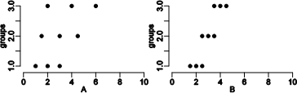
a. The MAD statistic is the same in A and B.
b. The MAD statistic is larger in A than in B.
c. The MAD statistic is smaller in A than in B.
d. We cannot tell if the MAD statistic will be larger in A or B.

5) College students tested to see how well knowing a person affects the ability to detect a lie from that person. To do this, the students came up with 10 statements about a person in the group. Five of these statements were True and five were False. The group tried to make up statements that nobody (not even close friends) would know if the statements were True or False. The students then presented these statements to people that fit in three groups: close friends, acquaintances, and complete strangers and counted how many statements each person correctly identified as True or False.
 | Sample size | Mean | SD
Close Friends (C) | 27 | 6.1 | 1.50
Acquaintance (A) | 31 | 4.8 | 1.58
Strangers (S) | 28 | 4.9 | 1.51

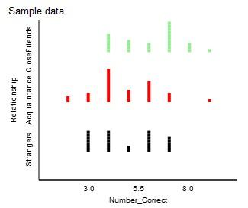
The Mean Group Diff statistic for this data set is 0.867. If the Mean Group Diff statistic had been smaller than the observed Mean Group Diff statistic, how would the strength of evidence change?
a. The strength of evidence against the null would increase.
b. The strength of evidence against the null would decrease.
c. The strength of evidence against the null would stay the same.
d. Cannot be determined.

6) College students tested to see how well knowing a person affects the ability to detect a lie from that person. To do this, the students came up with 10 statements about a person in the group. Five of these statements were True and five were False. The group tried to make up statements that nobody (not even close friends) would know if the statements were True or False. The students then presented these statements to people that fit in three groups: close friends, acquaintances, and complete strangers and counted how many statements each person correctly identified as True or False.
 | Sample size | Mean | SD
Close Friends (C) | 27 | 6.1 | 1.50
Acquaintance (A) | 31 | 4.8 | 1.58
Strangers (S) | 28 | 4.9 | 1.51

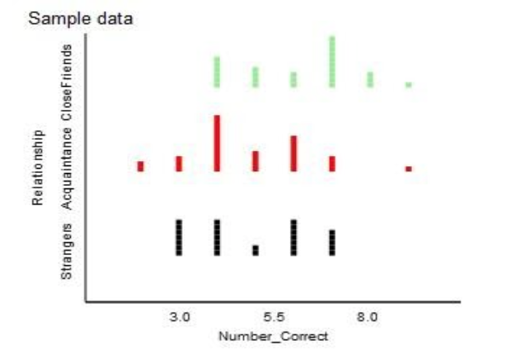
State the null and alternative hypotheses.
a. \( H_0: \mu_C = \mu_A = \mu_S\) versus \(H_A: \mu_C \ne \mu_A \ne \mu_S\)
b. \( H_0: \mu_C = \mu_A = \mu_S\) versus \(H_A:\) at least one \(\mu\) is different from the others
c. \( H_0: \overline{x}_C = \overline{x}_A = \overline{x}_S\) versus \(H_A: \overline{x}_C \ne \overline{x}_A \ne \overline{x}_S\)
d. \( H_0: \overline{x}_C = \overline{x}_A = \overline{x}_S\) versus \(H_A:\) at least one \(\overline{x}\) is different from the others

7) College students tested to see how well knowing a person affects the ability to detect a lie from that person. To do this, the students came up with 10 statements about a person in the group. Five of these statements were True and five were False. The group tried to make up statements that nobody (not even close friends) would know if the statements were True or False. The students then presented these statements to people that fit in three groups: close friends, acquaintances, and complete strangers and counted how many statements each person correctly identified as True or False.
 | Sample size | Mean | SD
Close Friends (C) | 27 | 6.1 | 1.50
Acquaintance (A) | 31 | 4.8 | 1.58
Strangers (S) | 28 | 4.9 | 1.51

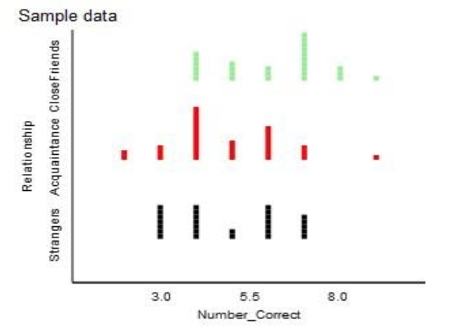
The Mean Group Diff statistic for this data set is 0.867. A null distribution was generated for this example and is shown below.
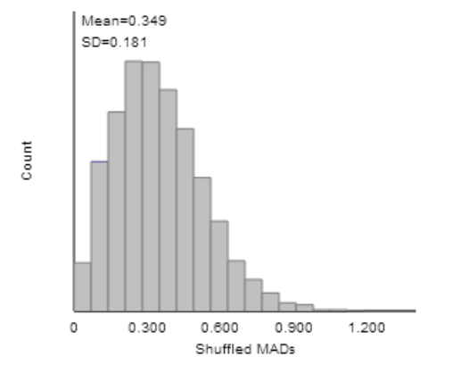
What is the strength of evidence against the null hypothesis?
a. Strong evidence against the null
b. Moderate evidence against the null
c. Weak evidence against the null
d. No evidence against the null

8) College students tested to see how well knowing a person affects the ability to detect a lie from that person. To do this, the students came up with 10 statements about a person in the group. Five of these statements were True and five were False. The group tried to make up statements that nobody (not even close friends) would know if the statements were True or False. The students then presented these statements to people that fit in three groups: close friends, acquaintances, and complete strangers and counted how many statements each person correctly identified as True or False.
 | Sample size | Mean | SD
Close Friends (C) | 27 | 6.1 | 1.50
Acquaintance (A) | 31 | 4.8 | 1.58
Strangers (S) | 28 | 4.9 | 1.51

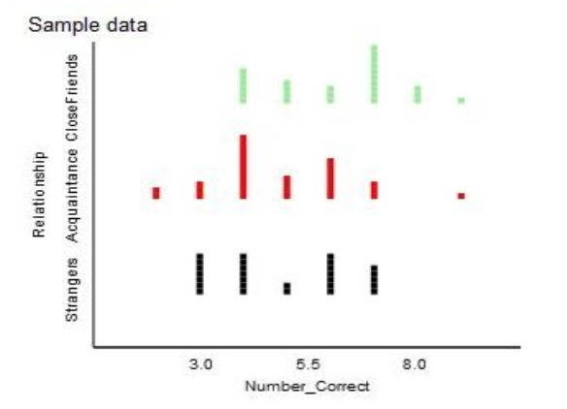
A null distribution was generated for this example and is shown.
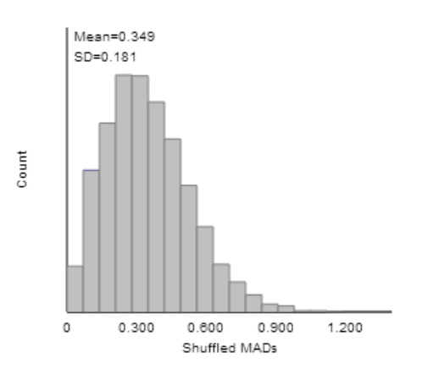
What is the shape of this distribution?
a. Normal
b. Symmetric
c. Left skewed
d. Right skewed

